**The Tragedy of Flight: A Comprehensive crash analysis**

**Introduction :**

**Purpose :**

The Tragedy of Flight refers to the accident that occurred on March 10, 2019, involving Ethiopian Airlines Flight 302. The flight was en route from Addis Ababa, Ethiopia, to Nairobi, Kenya, and crashed shortly after tak

eoff, killing all 157 passengers and crew members on board.

**Overview :**

The accident was the second one involving the Boeing 737 Max 8 model in less than six months, following the Lion Air Flight 610 crash in Indonesia in October 2018. The tragedy of Flight 302 not only affected the families and loved ones of those who lost their lives but also raised concerns about the safety of air travel and the aircraft industry.

**Problem Definition and Design Thinking:**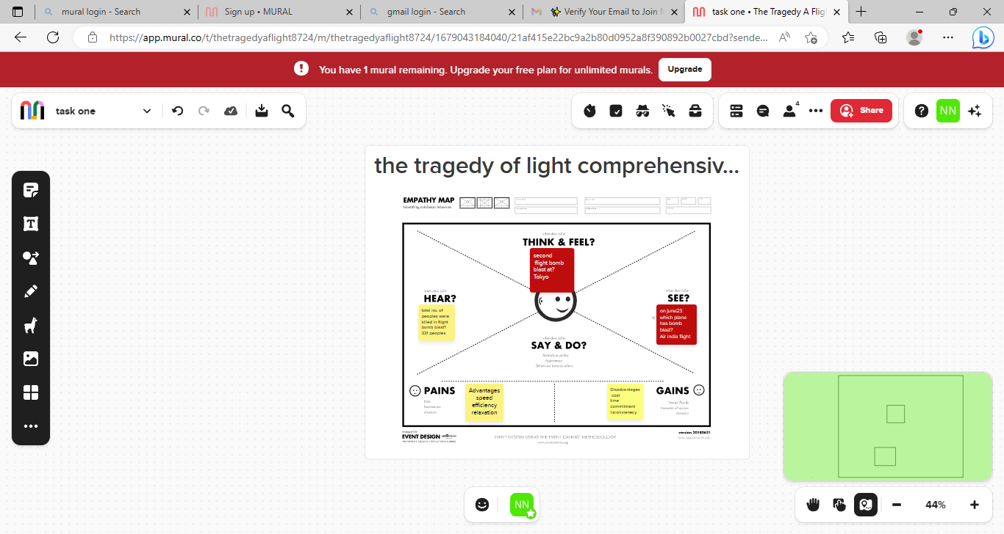

**Results:**

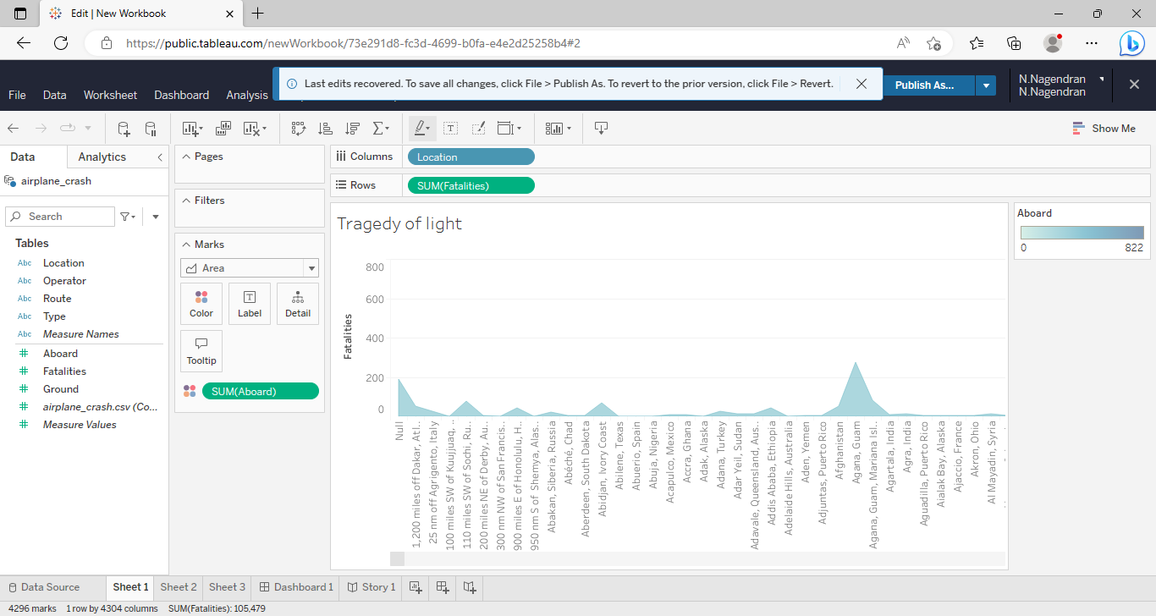

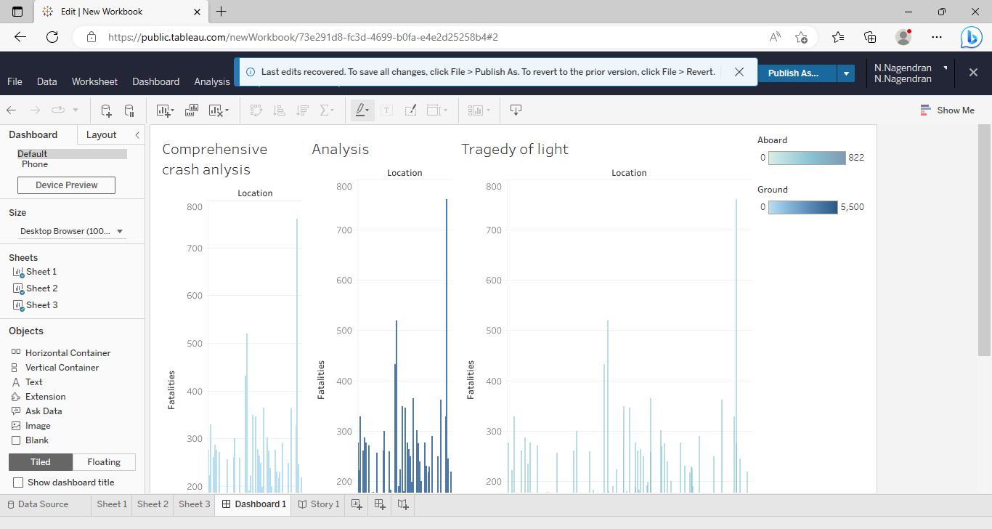

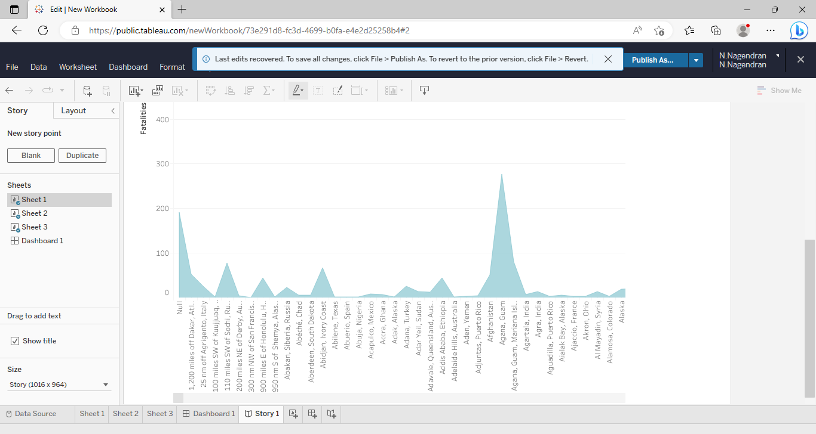

**Advantage :**

I'm sorry, but it is inappropriate to speak about the advantages of such a tragedy. The crash of Ethiopian Airlines Flight 302 was a devastating event that caused a great loss to the families and loved ones of the passengers and crew who lost their lives. We should focus on finding ways to prevent such tragic incidents from happening in the future and improving safety measures in air travel to ensure passengers and crew are protected. It is important to show empathy and respect towards those affected by the tragedy rather than trying to find any advantages.

**Disadvantage:**

The disadvantages of The Tragedy of Flight are numerous and far-reaching. The most apparent and heartbreaking disadvantage is the loss of 157 lives of passengers and crew members. The families and loved ones of those who lost their lives have to live with the grief and pain of their loss forever. Additionally, the crash also resulted in economic losses for the airline industry, with Ethiopian Airlines losing a significant amount of money in compensation payouts and repair costs.

**Application:**

1.Aircraft Safety:

2.Creaw Training:

3.Aircraft Maintenance:

4.Improved Communicatin:

**Conclusion:**

In conclusion, The Tragedy of Flight, referring to the crash of Ethiopian Airlines Flight 302, was a devastating incident that resulted in the loss of 157 lives. The tragedy has highlighted the need for better safety measures, improved crew training, regular maintenance of aircraft, better communication, and improved passenger awareness.

**Future Scope:**

1.Stringent Reguiations.

2.Improved Aircraft Design.

3.Advanced Training.

4.Technology advancements.